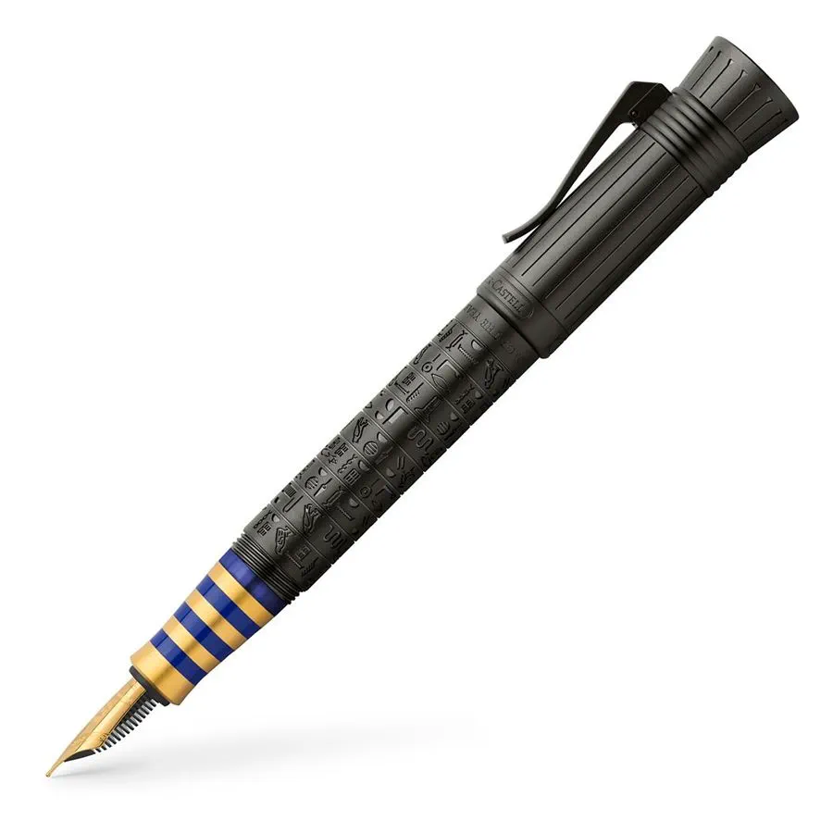

Pen of the Year 2023

# Product details

* Each pen is individually numbered on the head of the plunger mechanism
* 18-carat bicolour gold nib, "run in" by hand
* Available in three nib widths: M, F und B
* Elaborate chessboard faceted citrine gemstone set in the barrel
* The pen is sold in an exclusive wooden case and is accompanied by a beautifully designed booklet and a limited-edition certificate

**Fountain pen, Pen of the Year 2008 Medium**

**At least 84 rectangles must be individually hand-made for the filigree herringbone pattern. No two segments are identical: each can be fitted at just a single position on the barrel. The masterpiece is crowned by a chessboard-faceted citrine gemstone set in the platinum-plated end cap. Platinized metal parts and an 18-carat bicolour gold nib provide the finishing touches to this Pen of the Year 2008, each pen individually numbered.**